Pencil Sharpener

**Upon completion of the exploit, users will always have to perform an EC power reset by pressing refresh + power instead of restarting. This will prevent RO verification from bricking the device.**

**Pictures were taken from other devices and documentation and should have no relation to FCPS chromebooks.**

# Introduction

This writeup demonstrates how Google's tsunami enrollment patch, released on v114, can be bypassed on newer mainboards. The exploit still uses a modified version of the original pencil exploit in order to bypass FWMP and prevent the system from bricking.

# The Exploit

What you need:

- A pencil or some conductive material (chip clip recommended)

- A screwdriver and preferably an ESD bracelet to prevent damage to the device

- A sh1mmer image for your device flashed to an SD card or USB stick

We can first start by removing all screws on the bottom of the device to gain access to the mainboard. You should then find the battery, and proceed to disconnect it from the motherboard and the Write Protection (WP) module.

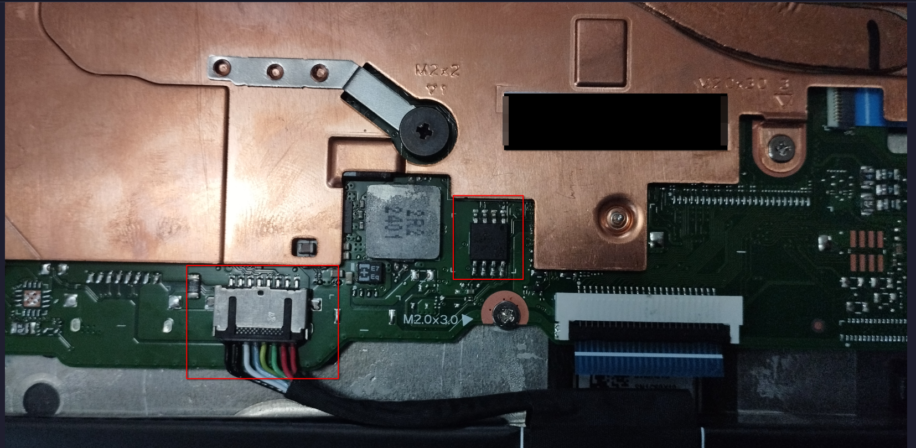

Now proceed to attach your conductive material, or chip clip to the WP module and then proceed to bridge pins 3 & 8. Then (WHILE KEEPING THE PINS BRIDGED) plug in your system and access the Chrome recovery menu by pressing esc + refresh + power and insert your sh1mmer drive.

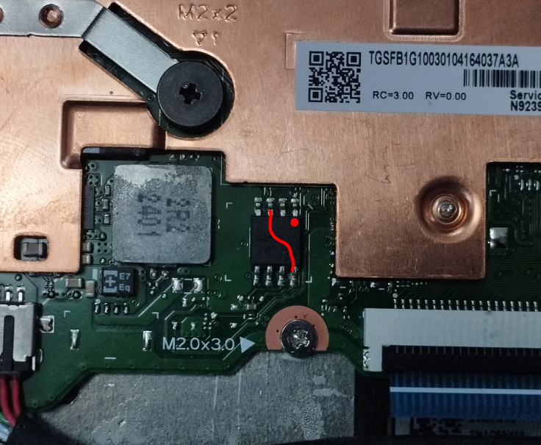

The system should eventually boot to the sh1mmer system menu. Choose the option to unenroll the device. This should give an error, but is needed to remove the block_devmode FWMP flag. Then open the sh1mmer bash console and run flashrom --wp-disable. If this throws an error, make sure the pins are still correctly bridged on the WP module and try again. Then run usr/share/vboot/bin/set_gbb_flags.sh 0x80b3 and reboot with esc + power into the dev mode menu.

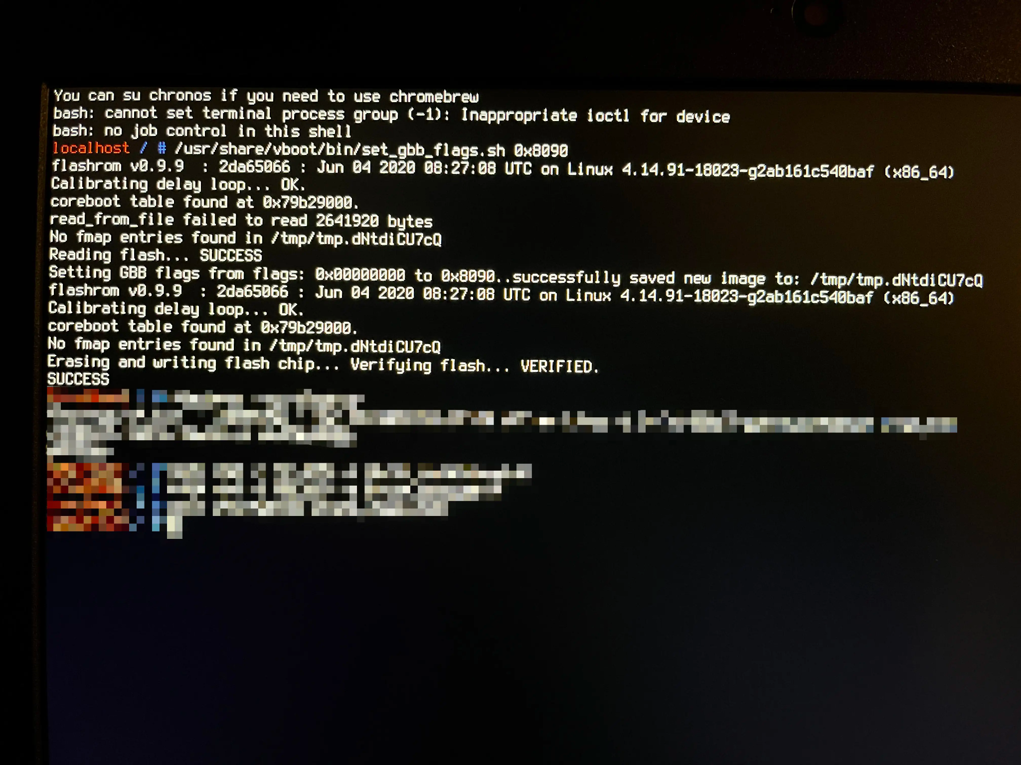

Now choose to boot from the external drive back onto sh1mmer and reopen the bash shell. Then, run tpm_manager_client take_ownership and cryptohome --action=remove_firmware_management_parameters to disable FWMP. Afterward, reboot with esc + power and choose to boot into internal storage (ChromeOS).

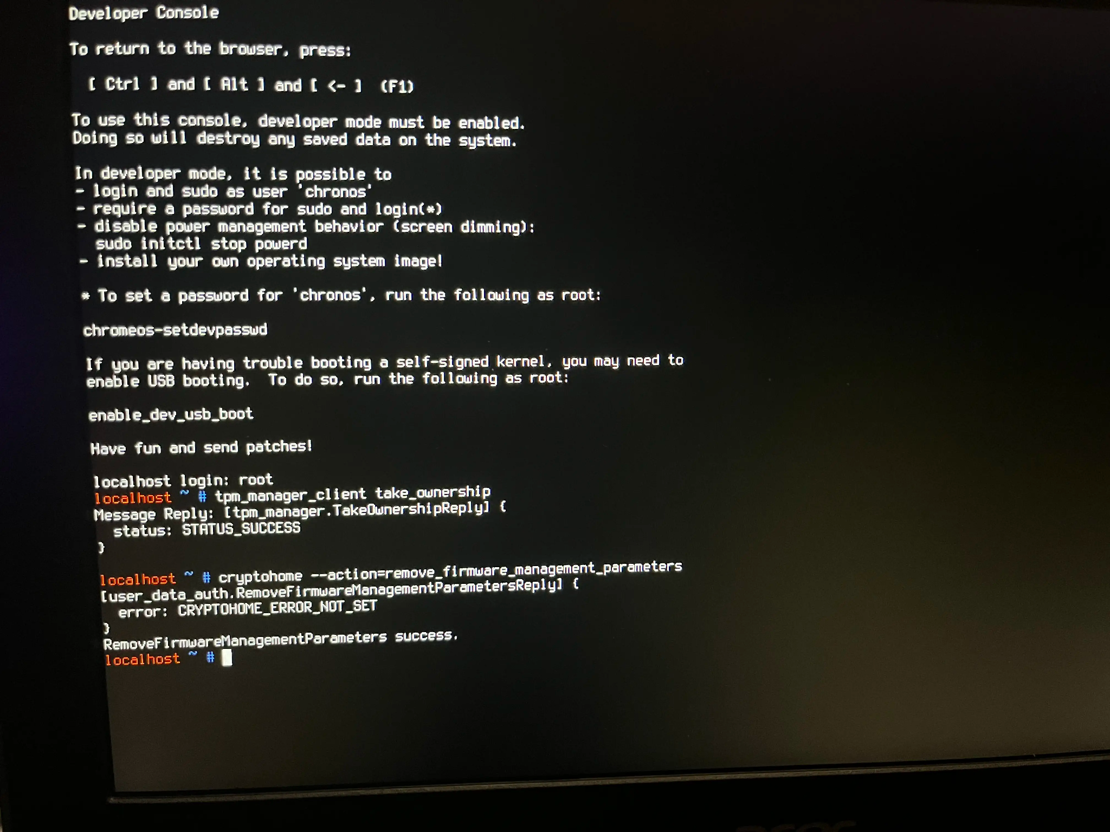

Now the system should attempt to enable developer mode. If this does not appear for you, open the recovery menu with esc + reload + power and then press ctrl + d. Afterward, you should now have access to the vt2 console and should no longer need the sh1mmer drive. THE BATTERY SHOULD STILL BE DISCONNECTED AT THIS POINT! Open the console with

Ctrl + Alt + → and run gsctool -a -o. The device should then automatically reboot.

The device should have been switched back to verified mode, so enter the recovery menu after booting to chromeOS and then re-enter dev mode by pressing ctrl + d and then enter on the screen. Re-enter the VT2 menu and run gsctool -a -I AllowUnverifiedRo:always.

If the instructions were followed properly, the device should have been fully unenrolled. You can now re-install the system battery and put the laptop back together.